Java Stream API

1. Introduction
The Stream API was introduced in Java 8.
It is used to process data from collections (like List, Set, Map), arrays, or I/O sources in a declarative (functional programming) style instead of using loops.
2. What is a Stream?
- A Stream is a sequence of elements that supports various operations to perform computations.
- It does not store data; it processes data from a source.
- Operations on streams are pipelined and executed only when a terminal operation is called.
3. Stream Pipeline
A stream pipeline has three stages:
- Source → Data (Collection, Array, I/O).
- Intermediate Operations → Transformations (filter(), map(), sorted(), etc.).
- Terminal Operation → Produces a result (collect(), forEach(), reduce()).
- Stream Creation
Streams can be created from different sources:
Example:
import java.util.*;
import java.util.stream.*;
public class StreamCreation {
public static void main(String[] args) {
List<String> list = Arrays.asList("A", "B", "C");
Stream<String> stream1 = list.stream();
String[] arr = {"X", "Y", "Z"};
Stream<String> stream2 = Arrays.stream(arr);
Stream<Integer> stream3 = Stream.of(1, 2, 3);
Stream<Integer> stream4 = Stream.iterate(1, n -> n + 1).limit(5);
stream4.forEach(System.out::println);
}
}
Output:
1
2
3
4
5
5. Intermediate Operations
Intermediate operations return a new Stream and are lazy (executed only when terminal op is called).
What are Intermediate Operations?
- Operations that transform a stream into another stream.
- They are lazy → executed only when a terminal operation is called.
- They do not consume the stream immediately.

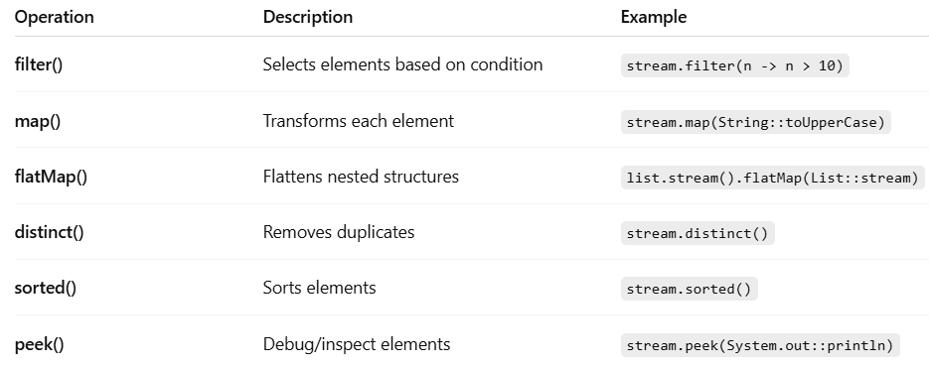

Example
import java.util.*;
import java.util.stream.*;
public class IntermediateOpsExample {
public static void main(String[] args) {
// Nested data (list of lists)
List<List<String>> data = Arrays.asList(
Arrays.asList("ravi", "amit", "raj"),
Arrays.asList("rakesh", "amit", "raju")
);

List<String> result = data.stream()
.flatMap(List::stream) // Flatten nested lists
.peek(n -> System.out.println("After flatMap: " + n))
.filter(n -> n.startsWith("r")) // Keep names starting with 'r'
.peek(n -> System.out.println("After filter: " + n))
.map(String::toUpperCase) // Convert to uppercase
.peek(n -> System.out.println("After map: " + n))
.distinct() // Remove duplicates
.peek(n -> System.out.println("After distinct: " + n))
.sorted() // Sort alphabetically
.peek(n -> System.out.println("After sorted: " + n))
.collect(Collectors.toList()); // Collect into list
System.out.println("\nFinal Result: " + result);
}
}

Expected Output
After flatMap: ravi
After flatMap: amit
After flatMap: raj
After flatMap: rakesh
After flatMap: amit
After flatMap: raju
After filter: ravi
After filter: raj
After filter: rakesh
After filter: raju
After map: RAVI
After map: RAJ
After map: RAKESH
After map: RAJU
After distinct: RAVI
After distinct: RAJ
After distinct: RAKESH
After distinct: RAJU
After sorted: RAJ
After sorted: RAJU
After sorted: RAKESH
After sorted: RAVI
Final Result: [RAJ, RAJU, RAKESH, RAVI]
Summary:
- filter() → Keep only matching elements
- map() → Transform elements
- flatMap() → Flatten nested streams
- distinct() → Remove duplicates
- sorted() → Sort elements
- peek() → Debug inside stream

6. Terminal Operations
What are Terminal Operations?
- They end the stream pipeline.
- They produce a result (like a value, a collection, or a side-effect such as printing).
- Once a terminal operation is executed, the stream cannot be reused.
Common Terminal Operations
- forEach() → Performs an action on each element.
- collect() → Collects elements into a collection (List, Set, Map).
- reduce() → Reduces elements into a single value.
- count() → Counts number of elements.
- anyMatch(), allMatch(), noneMatch() → Test conditions.
- findFirst(), findAny() → Return an element if present.
Example
import java.util.*;
import java.util.stream.*;
public class TerminalOpsExample {
public static void main(String[] args) {
List<Integer> numbers = Arrays.asList(1, 2, 3, 4, 5, 6, 7, 8, 9);
// 1. forEach - print numbers
System.out.println("forEach:");
numbers.stream().forEach(System.out::println);
// 2. collect - collect even numbers into a list
List<Integer> evens = numbers.stream()
.filter(n -> n % 2 == 0)
.collect(Collectors.toList());
System.out.println("\ncollect (even numbers): " + evens);
// 3. reduce - sum of all numbers
int sum = numbers.stream()
.reduce(0, Integer::sum);
System.out.println("\nreduce (sum): " + sum);
// 4. count - count odd numbers
long oddCount = numbers.stream()
.filter(n -> n % 2 != 0)
.count();
System.out.println("\ncount (odd numbers): " + oddCount);
// 5. anyMatch, allMatch, noneMatch
boolean anyGreaterThan5 = numbers.stream().anyMatch(n -> n > 5);
boolean allPositive = numbers.stream().allMatch(n -> n > 0);
boolean noneNegative = numbers.stream().noneMatch(n -> n < 0);
System.out.println("\nanyMatch (>5): " + anyGreaterThan5);
System.out.println("allMatch (>0): " + allPositive);
System.out.println("noneMatch (<0): " + noneNegative);
// 6. findFirst, findAny
Optional<Integer> first = numbers.stream().findFirst();
Optional<Integer> any = numbers.stream().findAny();
System.out.println("\nfindFirst: " + first.orElse(-1));
System.out.println("findAny: " + any.orElse(-1));
}
}
Expected Output:
forEach:
1
2
3
4
5
6
7
8
9
collect (even numbers): [2, 4, 6, 8]
reduce (sum): 45
count (odd numbers): 5
anyMatch (>5): true
allMatch (>0): true
noneMatch (<0): true
findFirst: 1
findAny: 1 // may vary

Summary
- forEach() → perform actions (like printing).
- collect() → gather results into collections.
- reduce() → combine elements into one value.
- count() → count elements.
- match operations → check conditions.
- find operations → get an element safely (using Optional).

7. Collectors Utility
What is Collectors?
- Collectors is a utility class in Java (java.util.stream.Collectors) that provides various methods to collect the results of a stream into different forms.
- Most commonly used with the terminal operation collect().
Why Use Collectors?
- To convert a stream back into a collection (List, Set, Map).
- To perform grouping, partitioning, counting, joining.
- To simplify complex data transformations.
Important Collectors Methods
- toList(), toSet(), toMap()
  - Collect elements into a List, Set, or Map.
- joining()
  - Concatenate strings with/without delimiter.
- counting()
  - Count the number of elements.
- summarizingInt(), averagingInt()
  - Get statistics (sum, average, min, max).
- groupingBy()
  - Group elements by a classifier (like SQL GROUP BY).
- partitioningBy()
  - Divide elements into two groups based on a condition.
Example:
import java.util.*;
import java.util.stream.*;
import static java.util.stream.Collectors.*;
public class CollectorsExample {
public static void main(String[] args) {
List<String> names = Arrays.asList("Ravi", "Rakesh", "Raj", "Amit", "Ankit", "Rohit");
// 1. toList
List<String> rNames = names.stream()
.filter(n -> n.startsWith("R"))
.collect(toList());
System.out.println("toList (Names starting with R): " + rNames);
// 2. joining
String joined = names.stream()
.collect(joining(", "));
System.out.println("joining: " + joined);
// 3. counting
long count = names.stream().collect(counting());
System.out.println("counting: " + count);
// 4. summarizingInt (length of names)
IntSummaryStatistics stats = names.stream()
.collect(summarizingInt(String::length));
System.out.println("summarizingInt: " + stats);
// 5. groupingBy (group by first letter)
Map<Character, List<String>> grouped = names.stream()
.collect(groupingBy(n -> n.charAt(0)));
System.out.println("groupingBy: " + grouped);
// 6. partitioningBy (names longer than 4 chars)
Map<Boolean, List<String>> partitioned = names.stream()
.collect(partitioningBy(n -> n.length() > 4));
System.out.println("partitioningBy: " + partitioned);
}
}
Output:
toList (Names starting with R): [Ravi, Rakesh, Raj, Rohit]
joining: Ravi, Rakesh, Raj, Amit, Ankit, Rohit
counting: 6
summarizingInt: IntSummaryStatistics{count=6, sum=30, min=3, average=5.000000, max=7}
groupingBy: {A=[Amit, Ankit], R=[Ravi, Rakesh, Raj, Rohit]}
partitioningBy: {false=[Raj, Amit], true=[Ravi, Rakesh, Ankit, Rohit]}

Summary
- Collectors help in converting, grouping, joining, partitioning, and summarizing data.
- They make the Stream API behave like SQL operations (GROUP BY, COUNT, SUM).
- Widely used in real-world applications (report generation, analytics, filtering large datasets).

8. Parallel Streams
What are Parallel Streams?
- A Parallel Stream divides the data into multiple chunks and processes them in parallel threads.
- It uses the Fork/Join framework internally to split tasks and combine results.
- This can improve performance for large datasets.
Create a Parallel Stream
  - From a Collection
list.parallelStream()
  - From an existing Stream
stream.parallel()
Example: Parallel vs Sequential Stream
import java.util.*;
import java.util.stream.*;
public class ParallelStreamExample {
public static void main(String[] args) {
List<Integer> numbers = IntStream.rangeClosed(1, 10)
.boxed()
.collect(Collectors.toList());
// Sequential Stream
System.out.println("Sequential Stream:");
numbers.stream()
.forEach(n -> System.out.println(Thread.currentThread().getName() + " -> " + n));
System.out.println("\nParallel Stream:");
// Parallel Stream
numbers.parallelStream()
.forEach(n -> System.out.println(Thread.currentThread().getName() + " -> " + n));
}
}
Output
Sequential Stream:
main -> 1
main -> 2
main -> 3
main -> 4
main -> 5
main -> 6
main -> 7
main -> 8
main -> 9
main -> 10

Parallel Stream:
ForkJoinPool.commonPool-worker-1 -> 1
main -> 2
ForkJoinPool.commonPool-worker-3 -> 4
ForkJoinPool.commonPool-worker-2 -> 3
ForkJoinPool.commonPool-worker-5 -> 7
Summary
- Sequential Streams → one thread, ordered.
- Parallel Streams → multiple threads, faster for big data.
- Internally uses Fork/Join pool.
- Use carefully: parallel streams may cause overhead or unexpected order.

